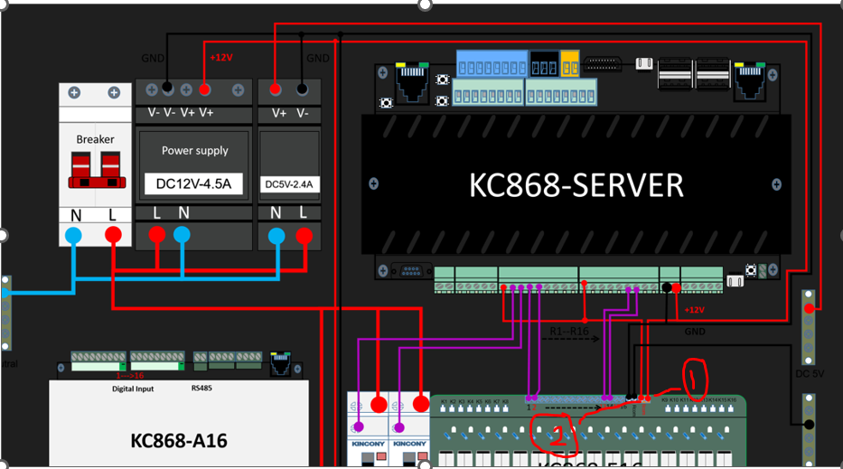

- No Power to K6868 Server – if I do wire connection like above (12v power supply Red cable wire + KC868 Server) – my connection photo below
- Red Cable connection (from E16 Module + P3 , P4 Output port on server)
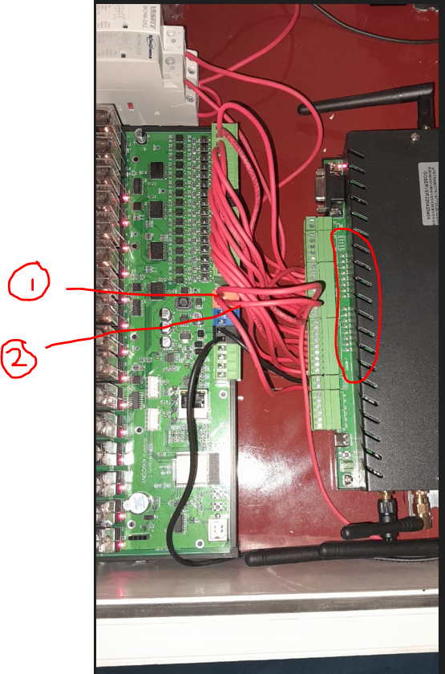

Note – From Home Assistant app – Output on/off --- not working
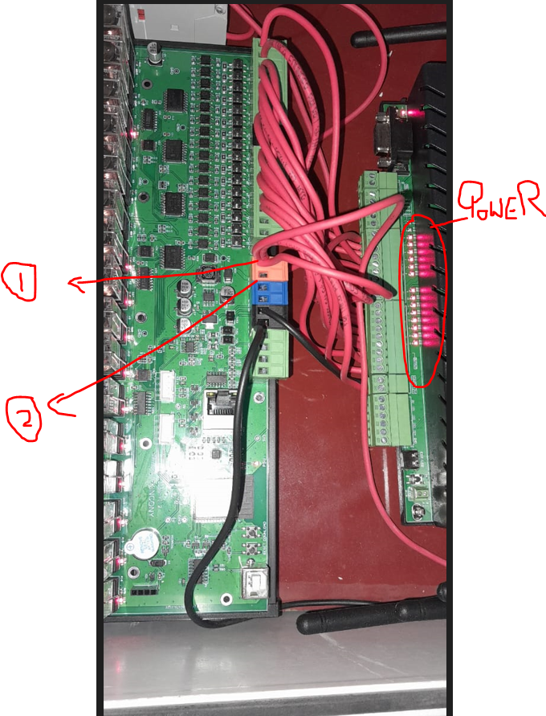

- 12v Supply Cable + KC868 server + P3,P4 Output Cable - all connect – Server have power NOW.
Note - Note – From Home Assistant app – Output on/off --- not working

