Water Level Indicator

* Use Platic pipe – make 3 point – ( GND wire – Input-1 wire – Input-2 wire)
* Digital Input – 1 ----- No Sensor use. I have use simple copper wire – roll it on pipe
* Digital Input – 2 ----- No Sensor use. I have use Simple Copper wire – roll it on pipe
* GND – No Sensor use. I have use simple copper wire - roll it on pipe

So I use the below idea to make Water level Indication

In the Water Tank –

* When water level is upto level 1 ( GND + Input-1 wire ) level it shown ON (input-1) – Indication of **HALF Tank**

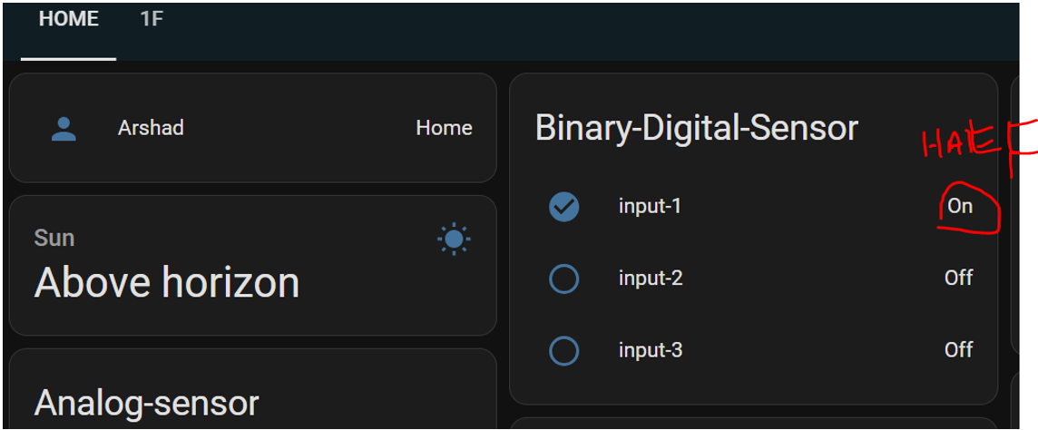

In the Water Tank –

* When water level is upto level 2 ( GND + Input-2 wire ) level it shown ON (input-1 ,input-2) – Indication of **Full Tank**

In the Water Tank –

* When water level is BELOW level 1 it shown OFF (input-1 ,input-2) – Indication of EMPTY **Tank**

